Ayush Sondhiya

installation and configuration

**Installation and configuration of openWRT router**

This installation and configuration will take place in the virtual box.

Before installation we need some prerequisites through which it will be easier to configure and setup the device later. The steps are mentioned to configure either below: -

* To configure virtualbox eitehrne adapter manually

( since the openWrt or any other software reuire the the physical wired conection for the installation and configuration purpose )

For that adapter configuration

1. Go to the virtual box > Tools > Network

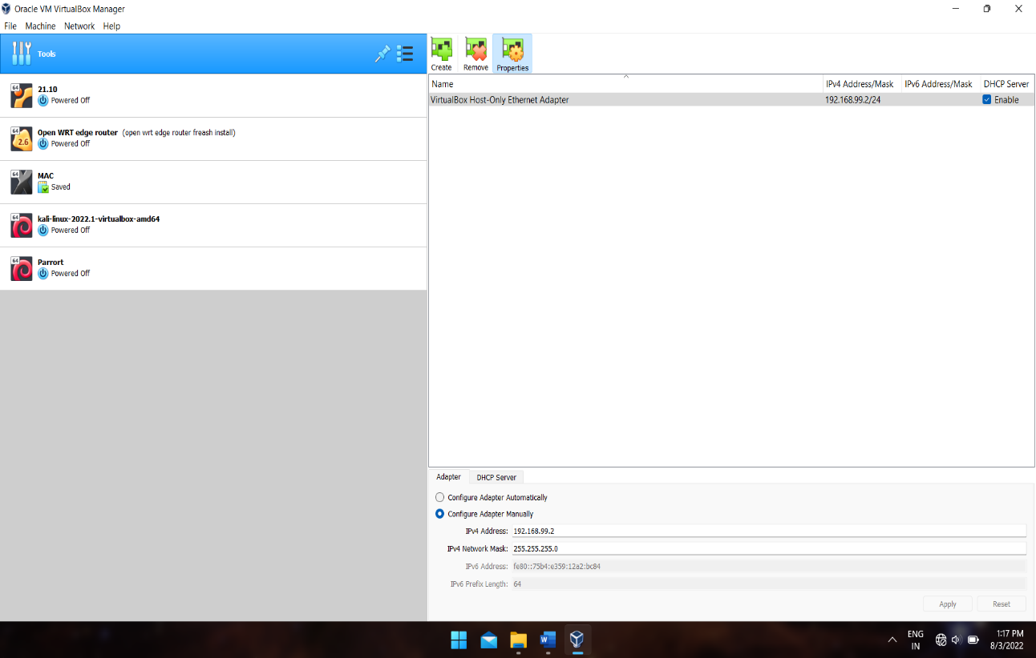

1. Go to adapter > Configure adapter manually
2. Change the IPv4 address to what ever you like

( in my case I have set it to 192.168.99.2 )

1. And then turn off the DHCP servers

(cause we don’t want our virtual machine to pass thoudh directly into the network , er want it to go through the virtual box Ethernet adapter or the the virtual adapter which we are going to configure)

1. Then restart the Virtual box to implement the changes

* **After installation launch the VM**
* Set the IP to 192.168.99.2
  + Using command : uci set network.lan.ipaddr=’(your ip you want to set)
* Then check the if its has updated
  + Using command : uci show network

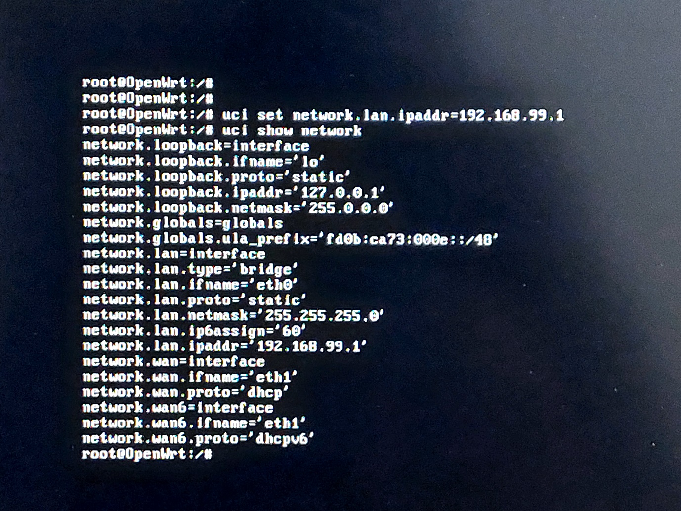



As in the above image the ip address has been updated sucesssfuly

* This is an important step as later we are going to to log in to the web interface using the the above ip address .
* After completing this process type the folowing commmands to finalize

The changes we have made this thisn far

* + Command : uci commit
* And to impliment the change in the routers firmaware use the commnd to reeboot the router
  + Command : reboot

And hit enter to reboot the router

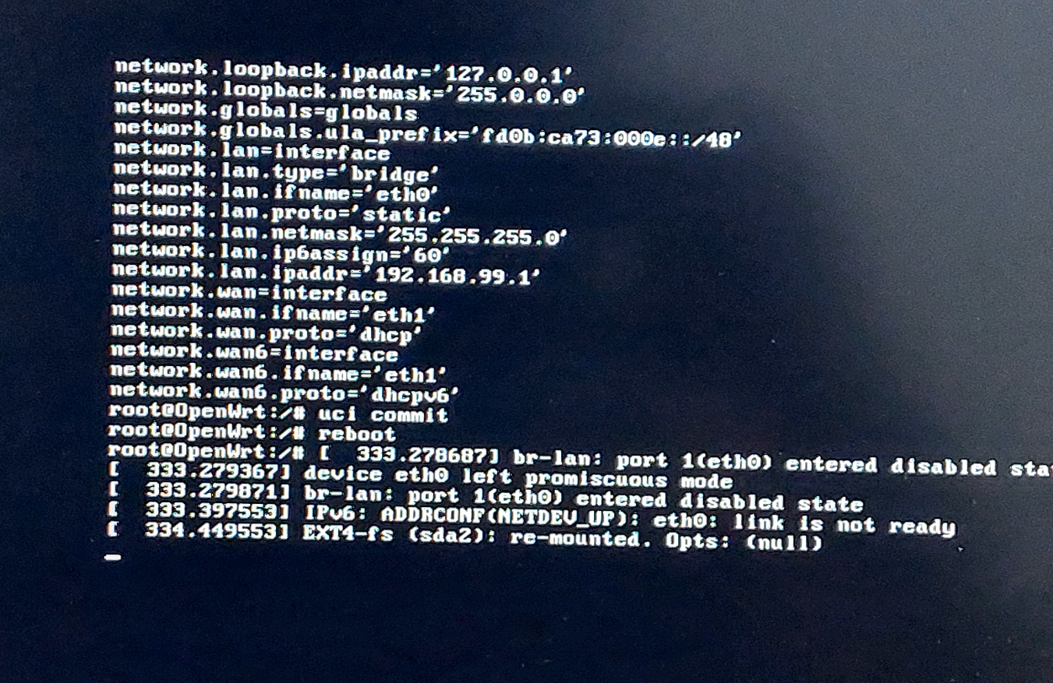

( in above sceenshot we used the the commmands to getthe routers ip fixed. )

* Use command :ip addr (to cross check if the updated ip addredd is showing in the port no 4 which is br Lan)

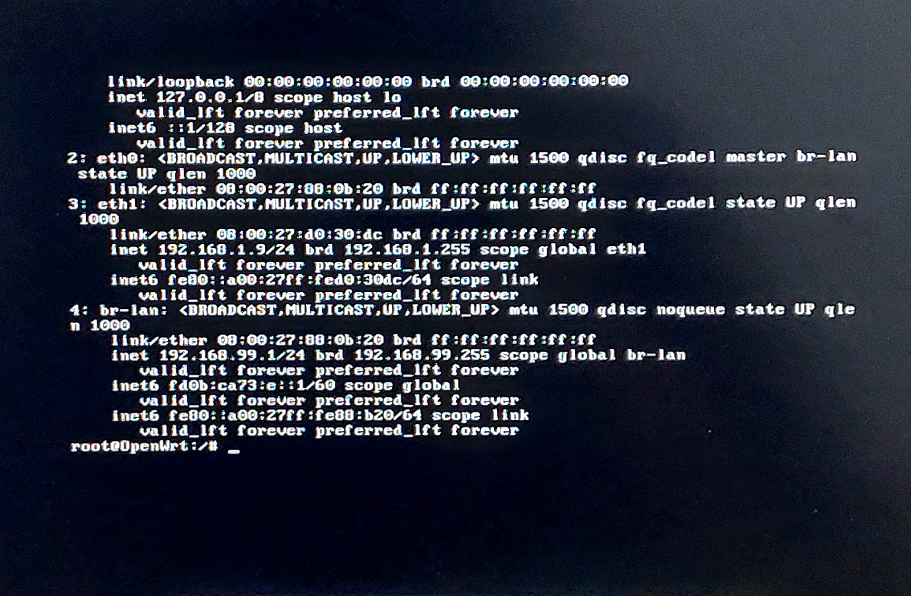

* Now lets try to ping the addresses
  1. Ping [www.google.com](http://www.google.com)

(to check if our brigged connector i workig or not)

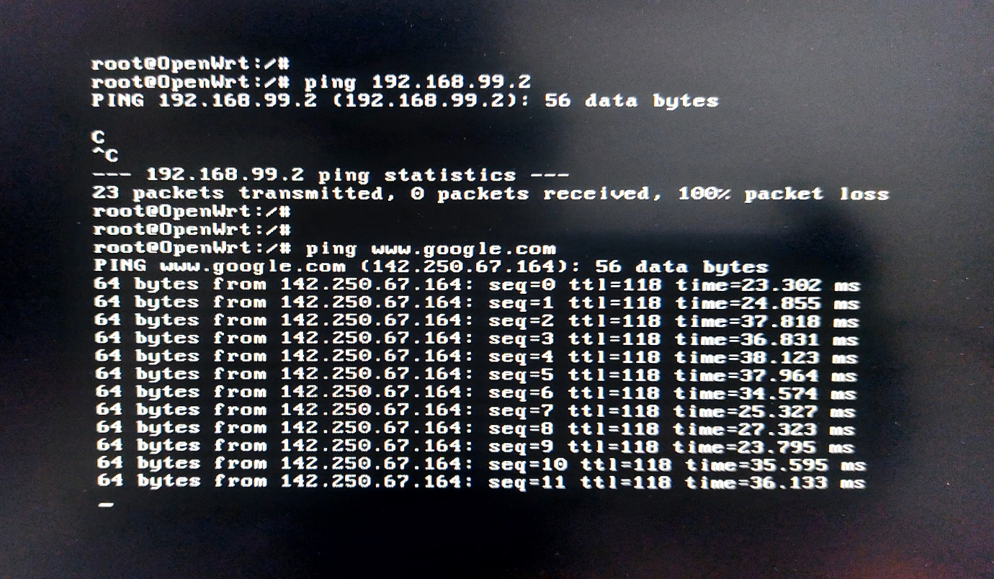

* 1. Ping 192.168.99.1

(to check out if the ip we set is up and running

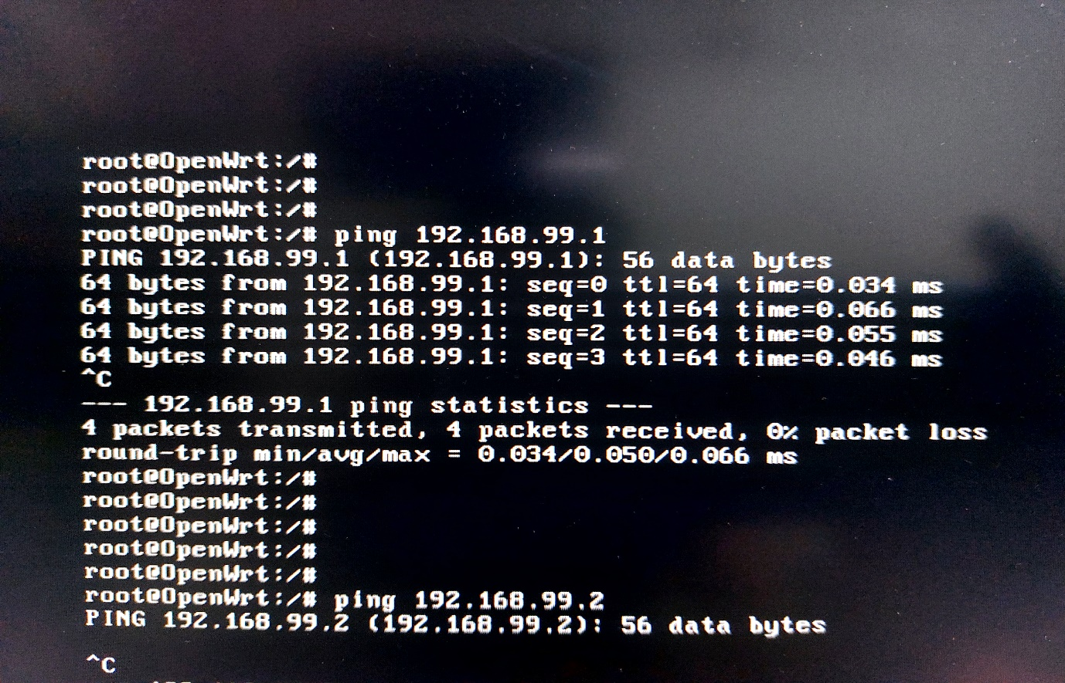

As we have checked previously that all the links are up and running thus,we will be able to log into the luci or the web based interface for the confihuration of the router.

And the (LUCI) web interface is user friendly to configure different scenerios and required protocols

* To enter web interface (LUCI)
  + Go to you web browser and then type the ip which will be required to open the web interface page

(im my case I was 192.168.99.1)

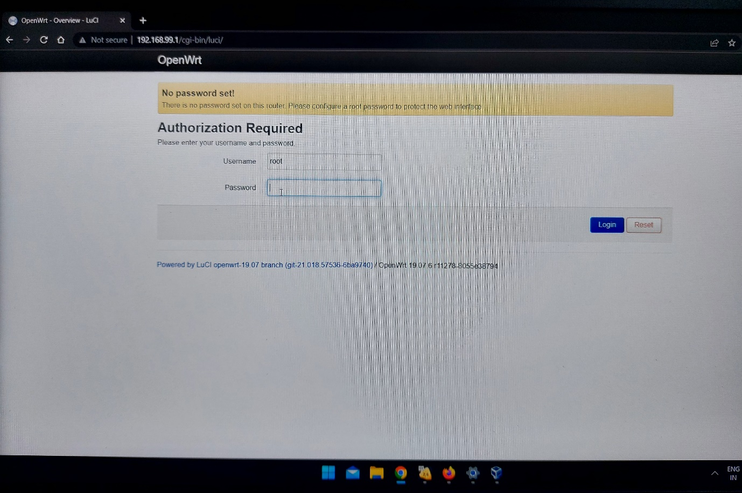

* + if you have created any sort of password at the timeof configuration of the device then you will required to enter it
  + or else hit enter to get into the get started with the interface

In the screen you will be able to see the all the basic information about the hardware and the software

* like the name of processor
* model number
* firmware version
* kernal version
* up time
* host name
* storage
* ram
* etc.

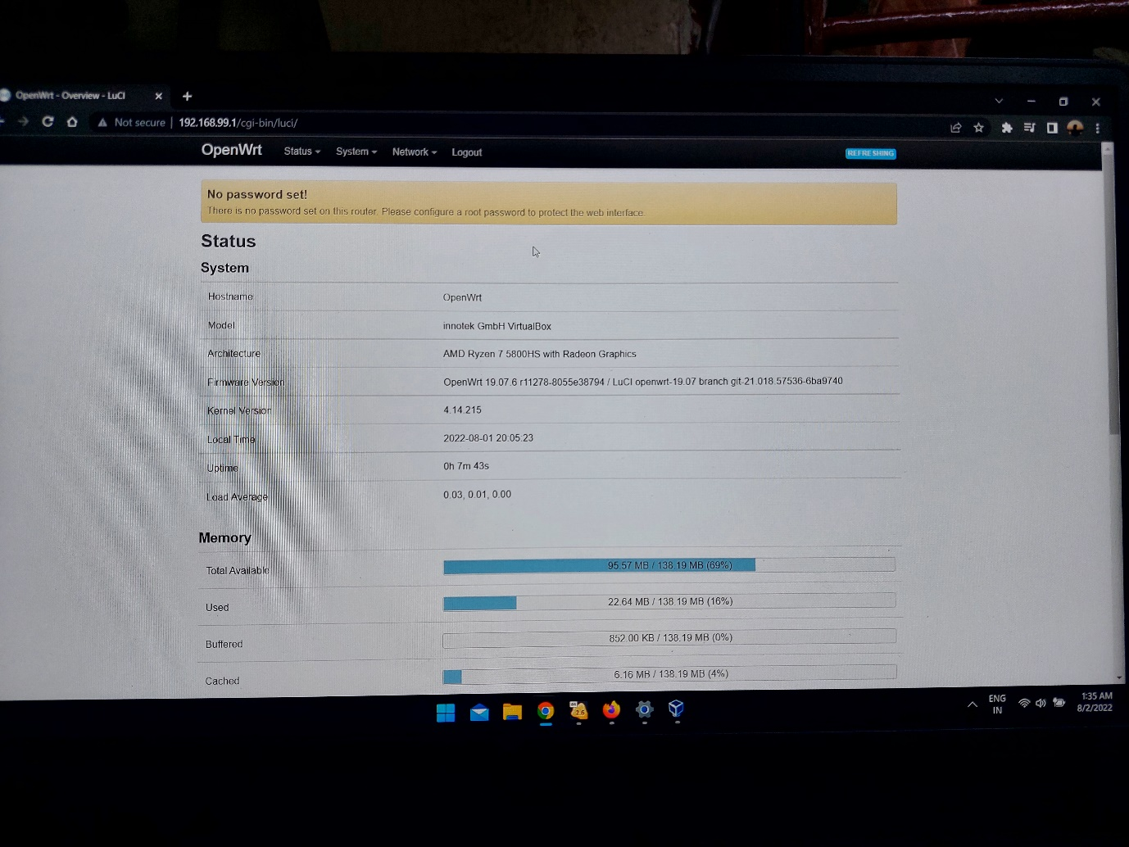

(The web interface should look like this)

We can see the network interface

* By navigating to
  + Network > Interfaces
  + Here we are able to see all the network link swhich are up and running
  + Here we can add or remove interface
  + Or we can change the ip of the address or simply restart them at that perticular page

a.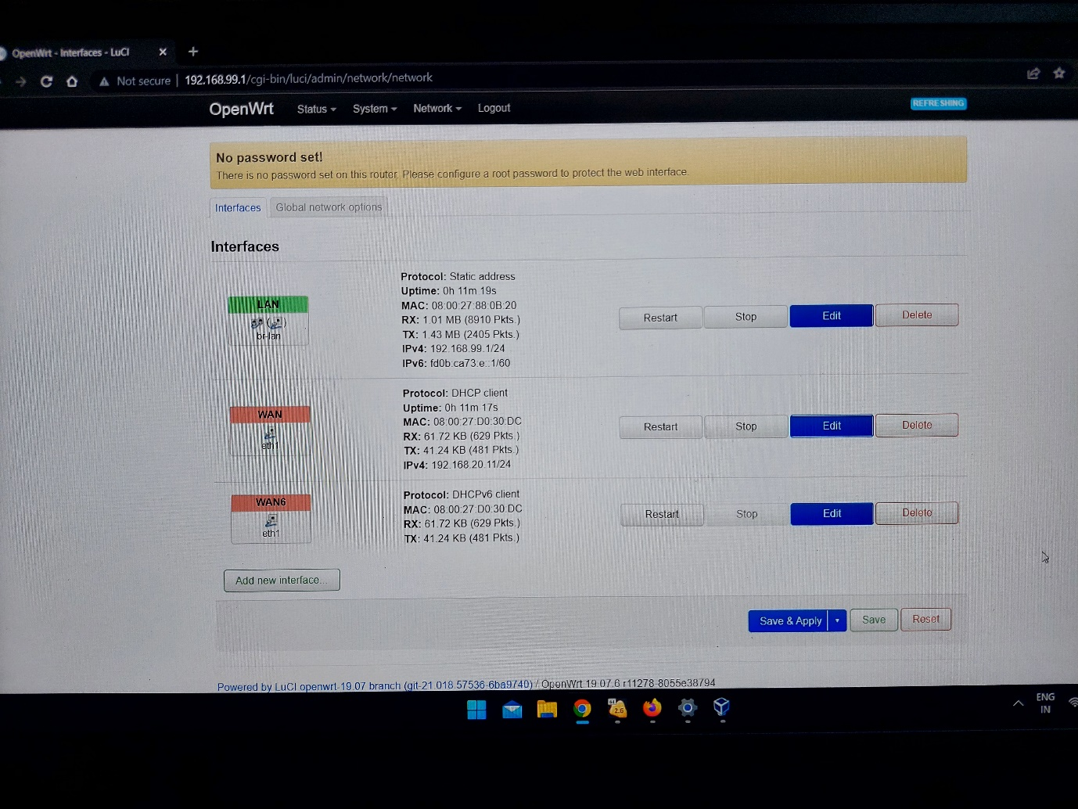

we can see the different aspects of the adapters

to setup the PPPoE connection protocaol

* We will have to navigate to the interface

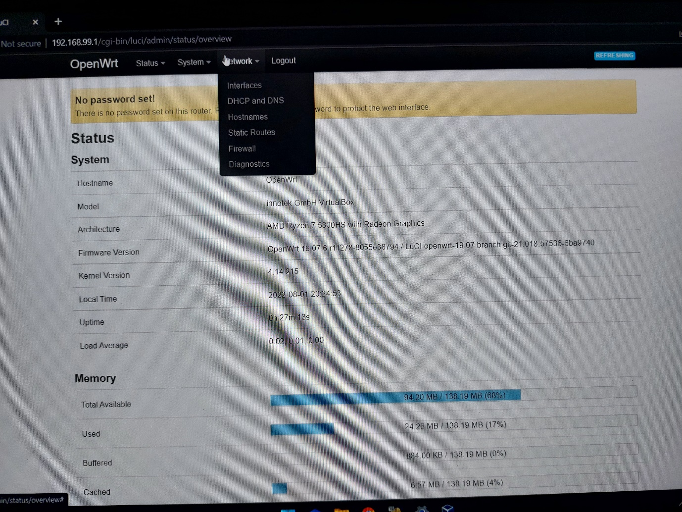

* + Navigate : Network > Interfaves
* Then go to the second adapter which says WAN
  + Stop the eth1 and then press on edit button
  + Change the DHCP protocaol to PPPoE protocol
  + Setup the name
  + Setup the password
  + And leave access contracrto to auto mode
  + Then restart that link and save and apply the setting

The steps has been shown in below slides in sequence

1 naviation

2 editing

3 saving the changes

1. 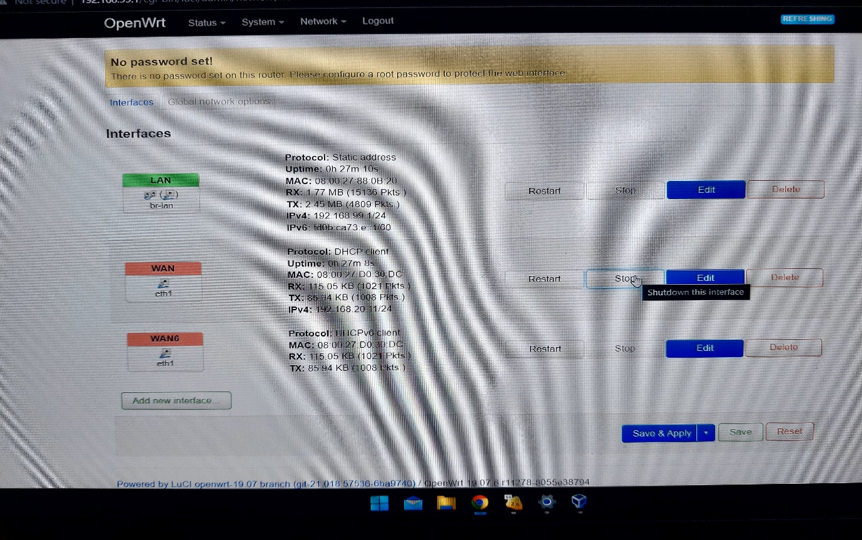To navigate and to ideantify the right adapter.
2. To change the the protocol from DHCP to PPPoE.

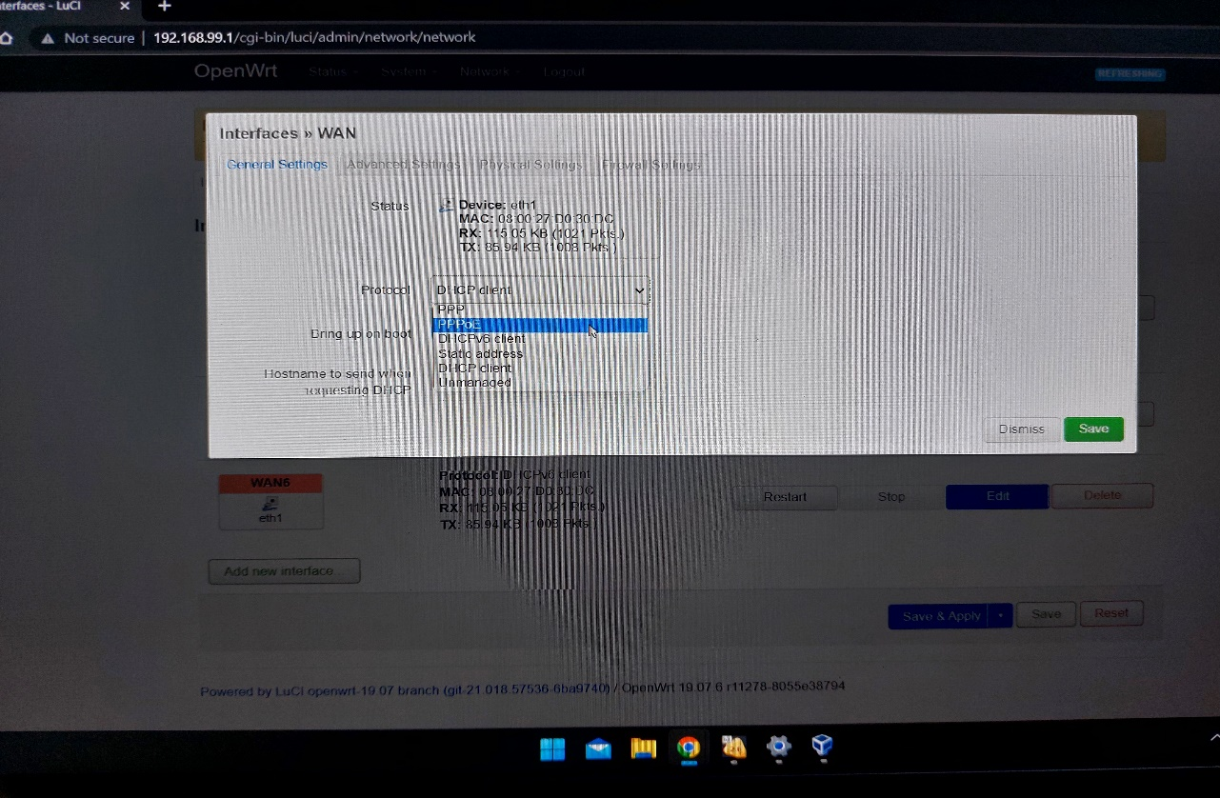

1. To add a username and pssword to the network adapter

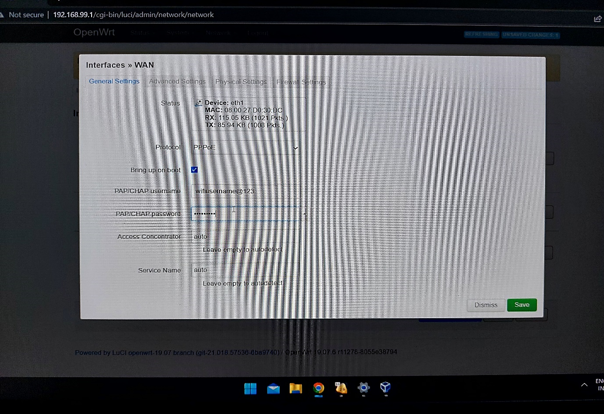

1. Then press save and apply to get the network running

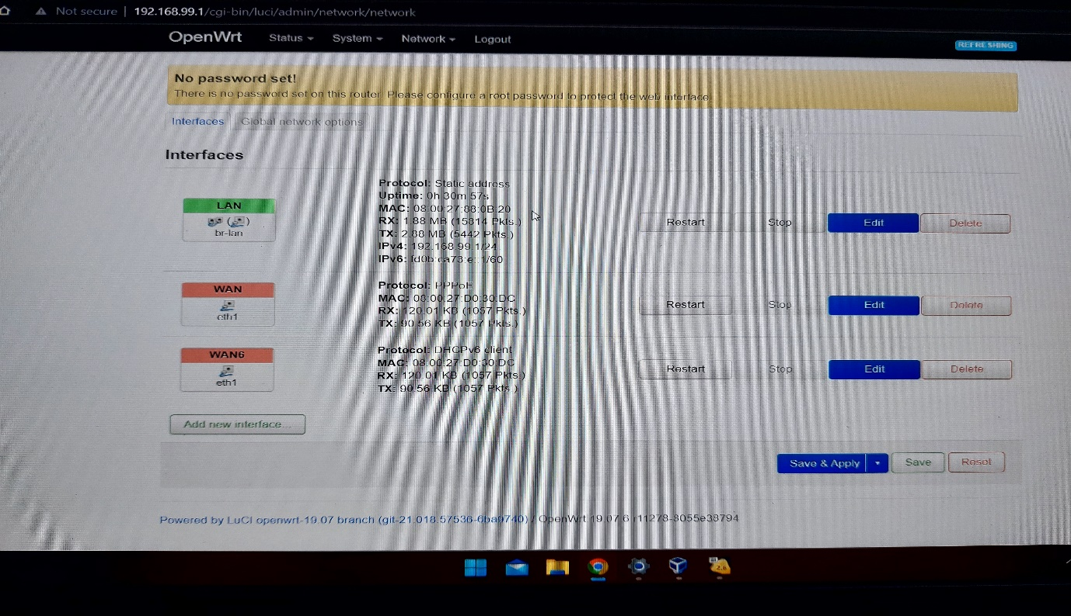

As we can see the protocal Is changed from DHCP to PPPoE.

To watch or keep a track of real time statitics of the network

* The open wrt provides the watch over real time statitics of the data trrafic that is passing through the router
  + To accces that information
  + Navigate status > realtime graphs for the data traffic

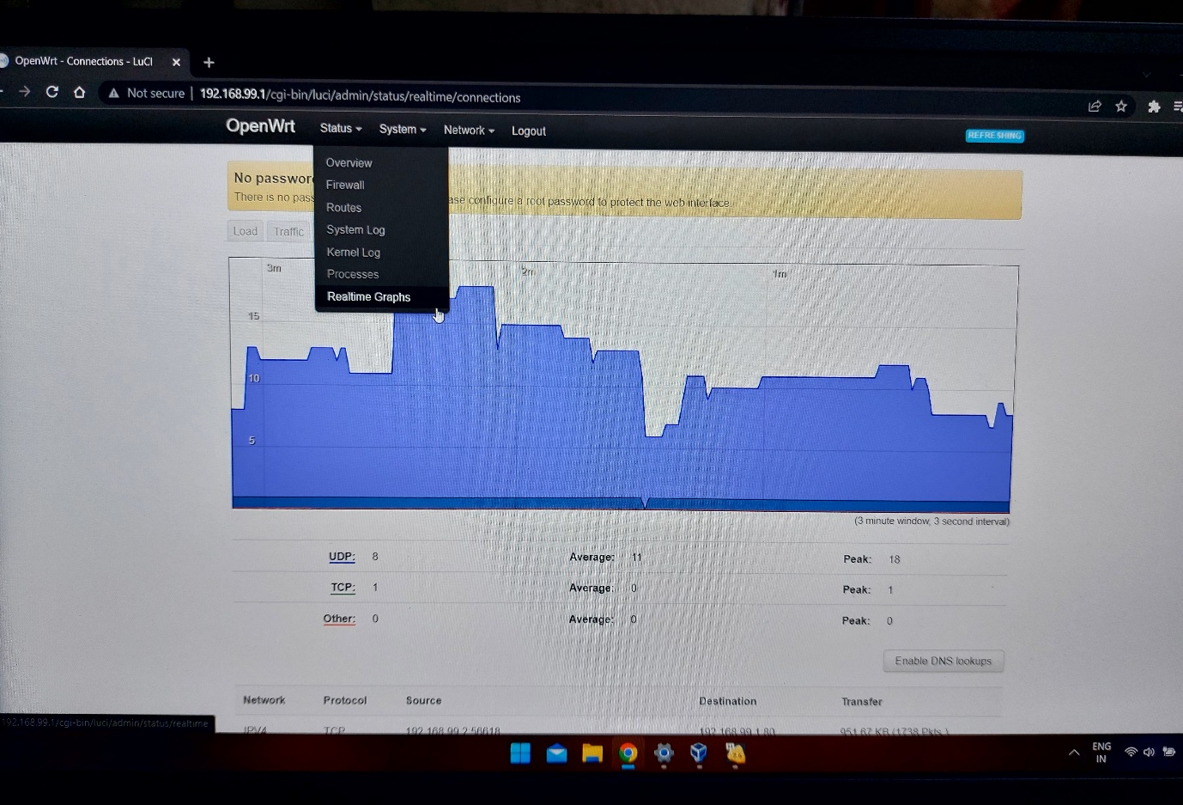

( the interface should look like this )

Here we can see the different attributes like

* Load
  + For different ethernat adapter or channels
* Traffic
  + The amount of data trannsferring across the network
* Connections

Image below is showing overall load on an adpter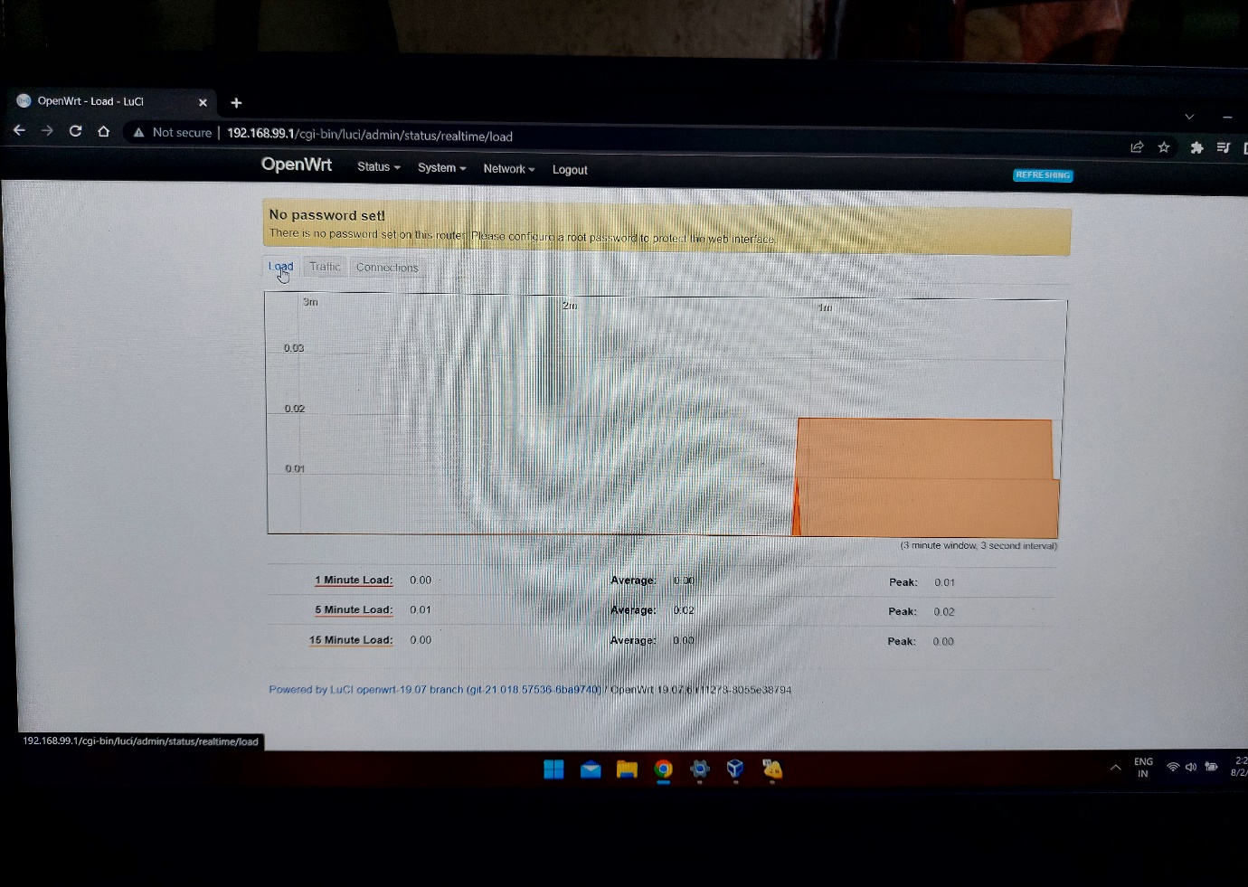

The below image shows the trrafi on particular port (eth0)

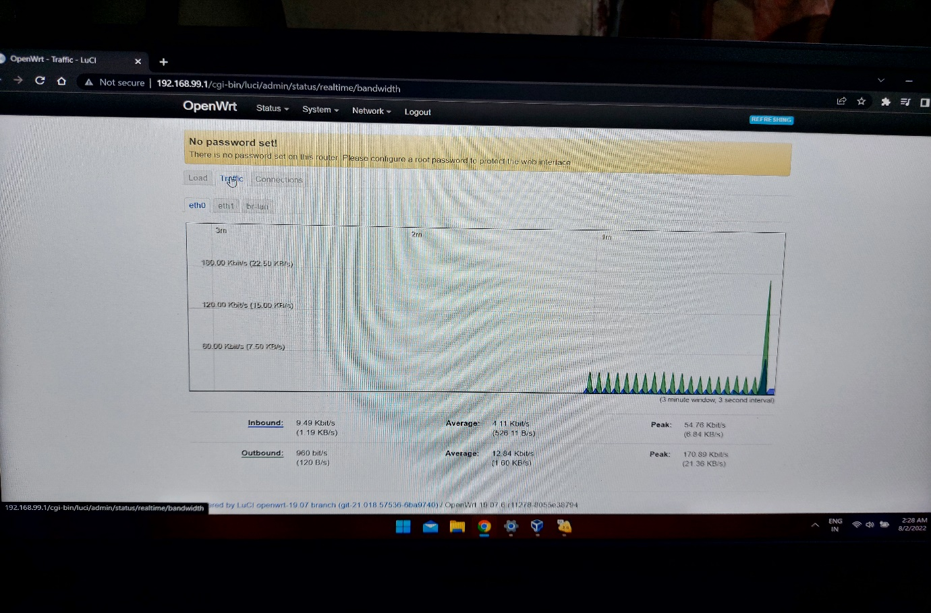

We can change the time, date,hostnaem timezone etc on thin open wrt with ease

* To do that
  + Navigate : system > system properties

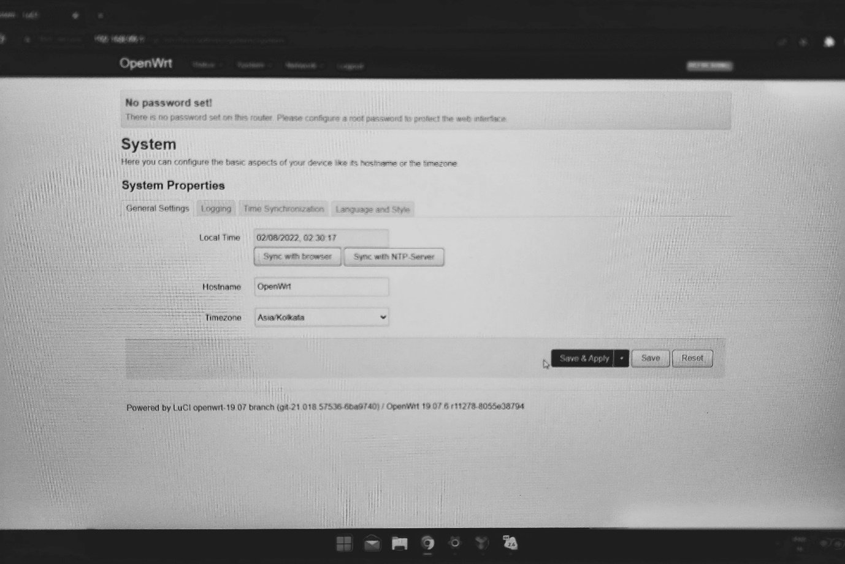

Or simply we can sync it with our current browser which already has an demographic data of our region

After completing all the changes press [save and apply] to finalize your settings. It will take some tiem to update any thing for faster configuration press the save button only and then later apply all the changes all togather.

This will save a lot of time since we have to do a lot of configration while setting up a new device

**System logs**

OpenWrt provides with a feature to see the system logs in the browser.which will be help.

To reach the system logs

* + Navigate : status > system log

There you can find all the system logs which are genetated in real time.

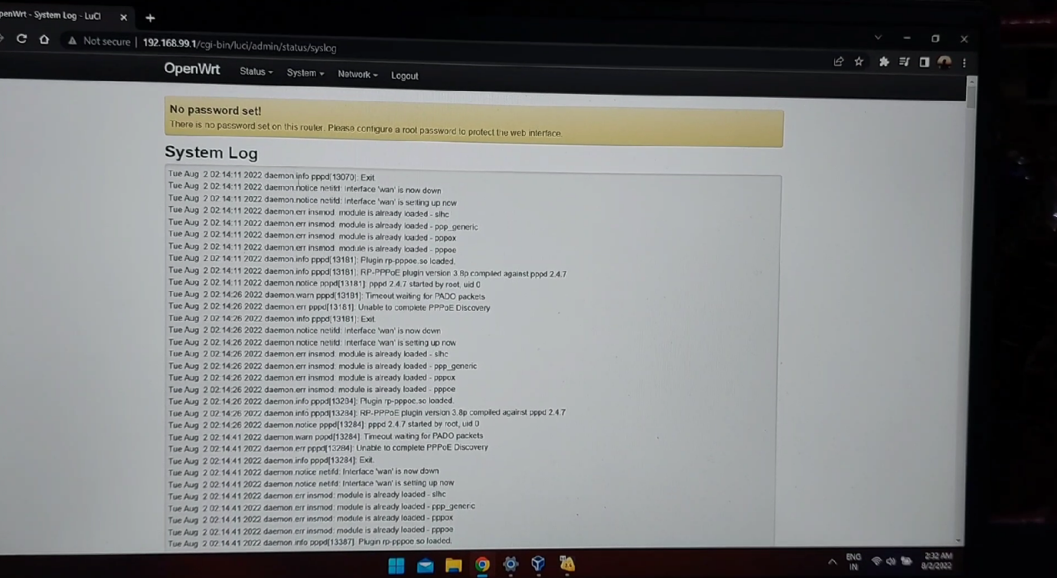

**DHCP AND DNS**

* DHCP stands for Dymaic host control protocol
* DNS stands for domain name service

Here we going to configure the network

We have to navigate to the DHCP and DNS in the network.

Navigate : network > DNCP and DNS

Here you can see the active DHCP lease and active and active DHCPv6 leases

And or add the new lease lines, and configure them by our self.

* all the DHCP leases are shown Below

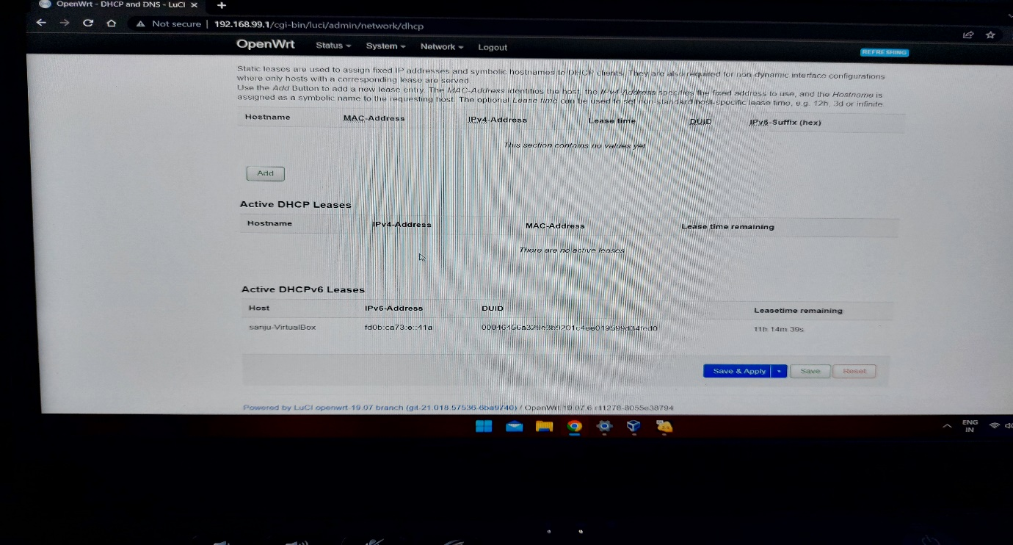

* Set the ipv4 address to the intial ip address that we have enders while configuration
* Change hostname , add leasetime as 0 so the link time will be infinite

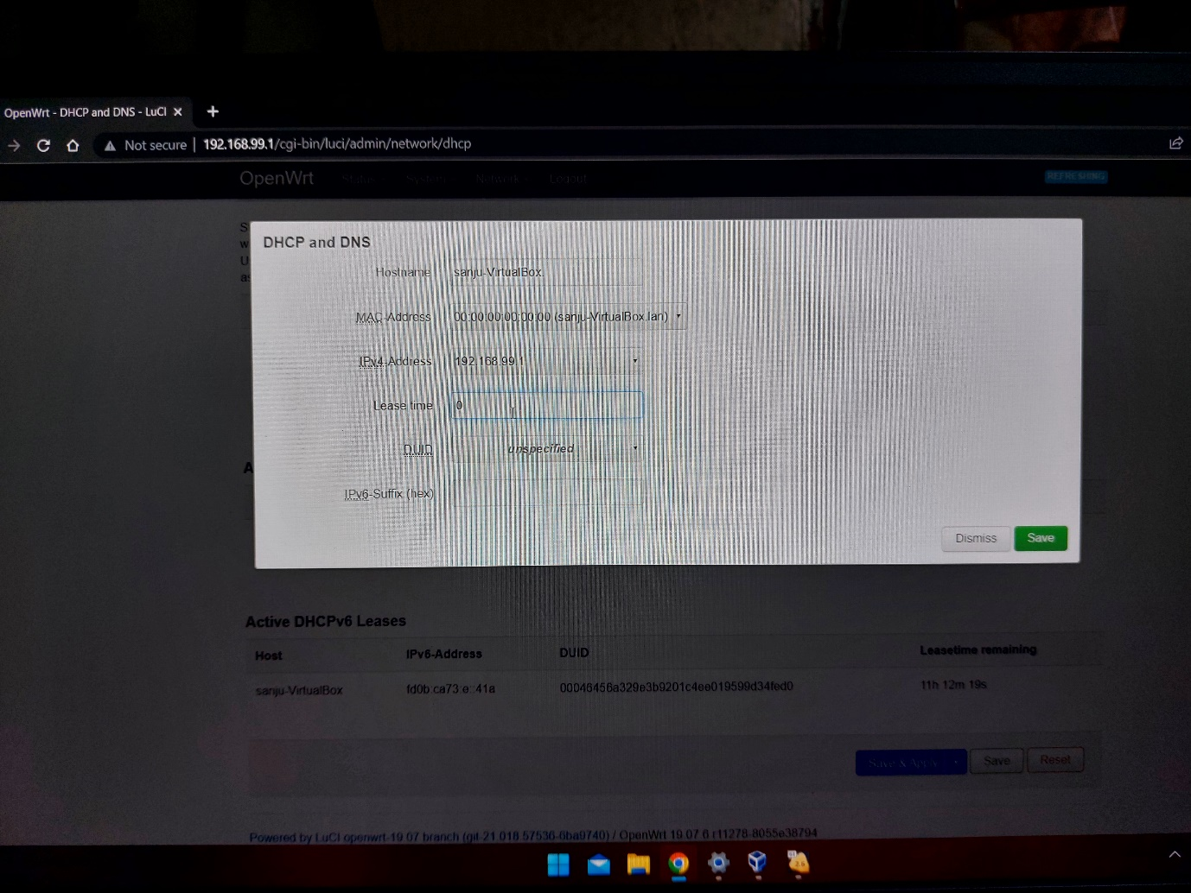

**Firewall**

The firewall forms a layar over your nework which allows or rejects the incoming data form outer sources

Here we will see to rediredt the network flowto the internal host

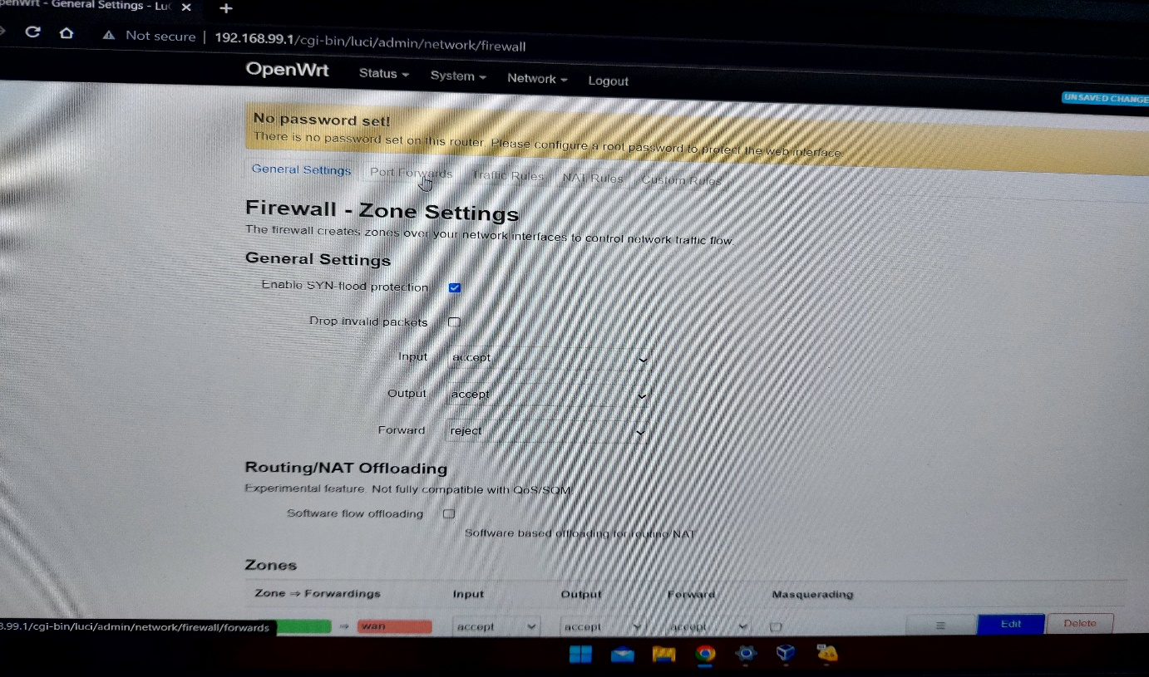

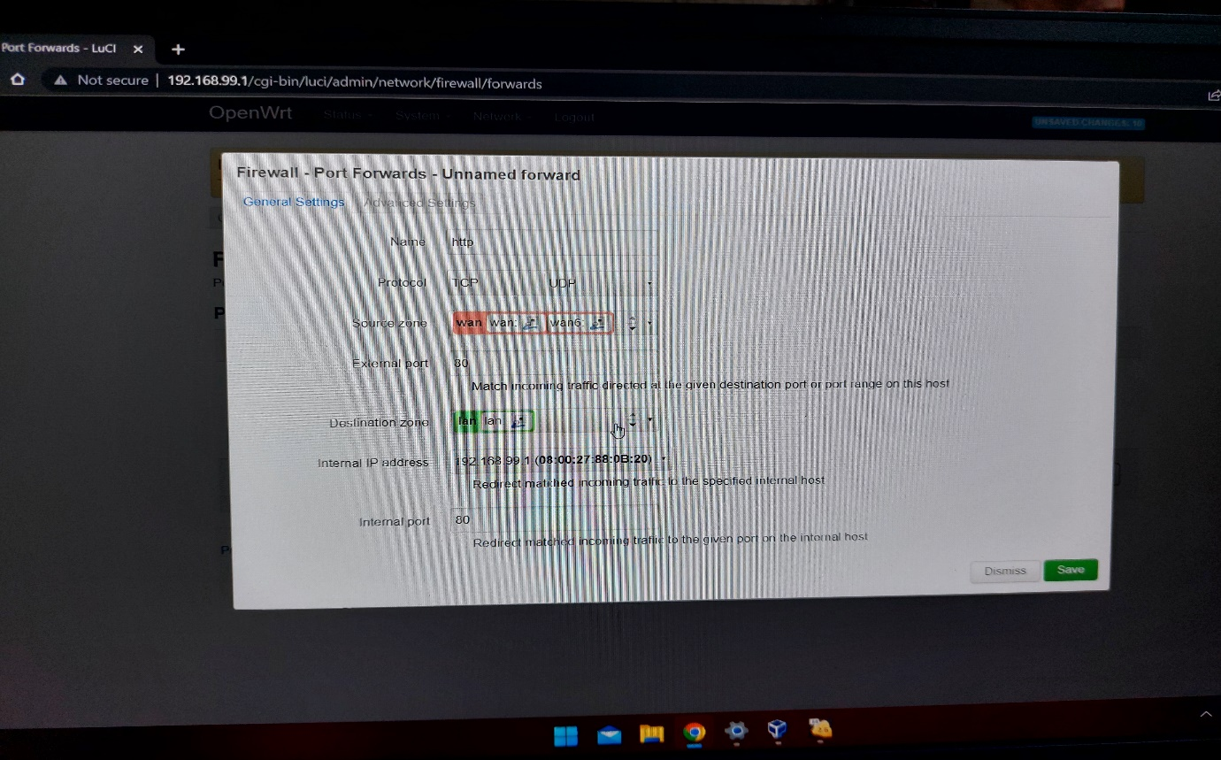

**Changing the lan’s ip address**

As of now we are using the ip 192.168.99.1 to login to the LUCI portal

But we can also change the root ip for the router login .We can change the host ip by following steps

* Navigate : network > interfaces
* Choose the lan adapter
* Click on edit

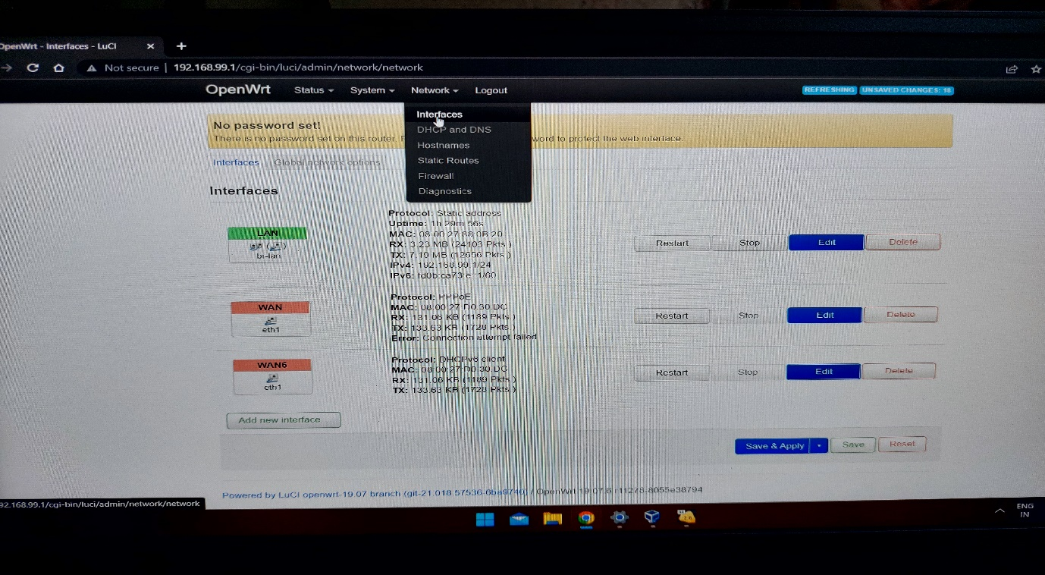

* Change the ip address
* And you are good to go

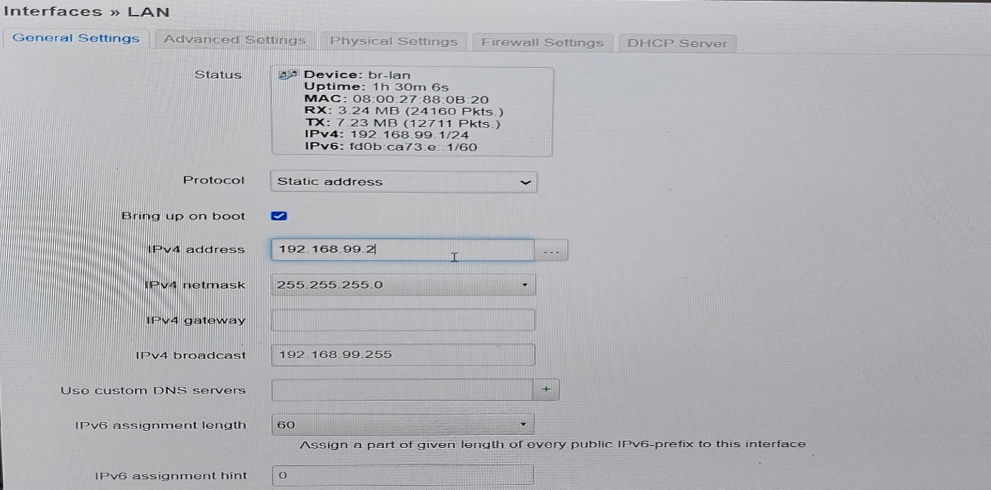

**Flash or update the router fimware / Flash the firmware**

* First we have to download the exact version which is supported by uor hardware

( in our case it will be the x86 version )

* As we click on the required hardware version download the upfate file via an update image link

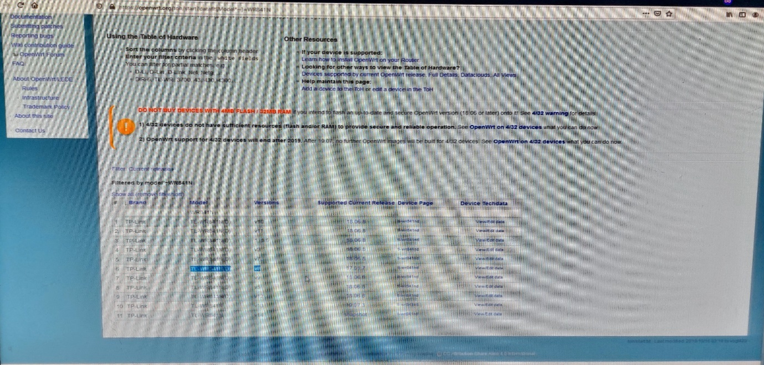

You will get a link like this for update version

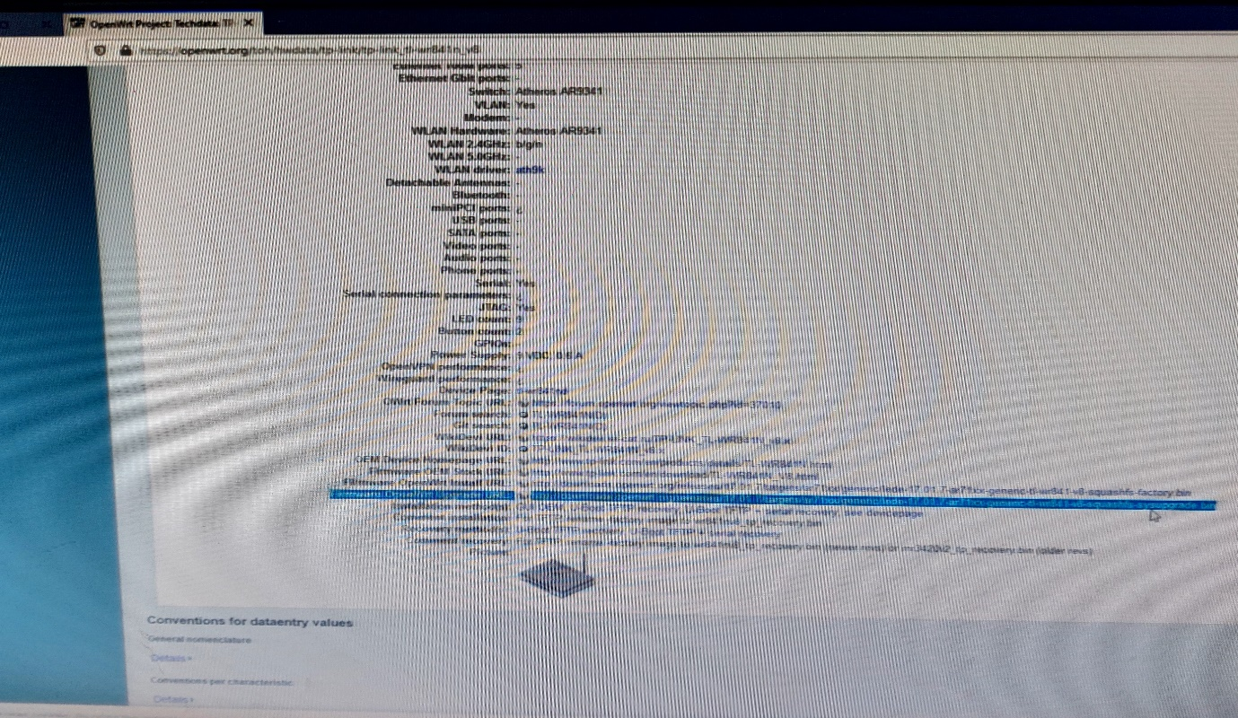

* To update the firmware in the router
  + Navigate : system > Backup/Flash

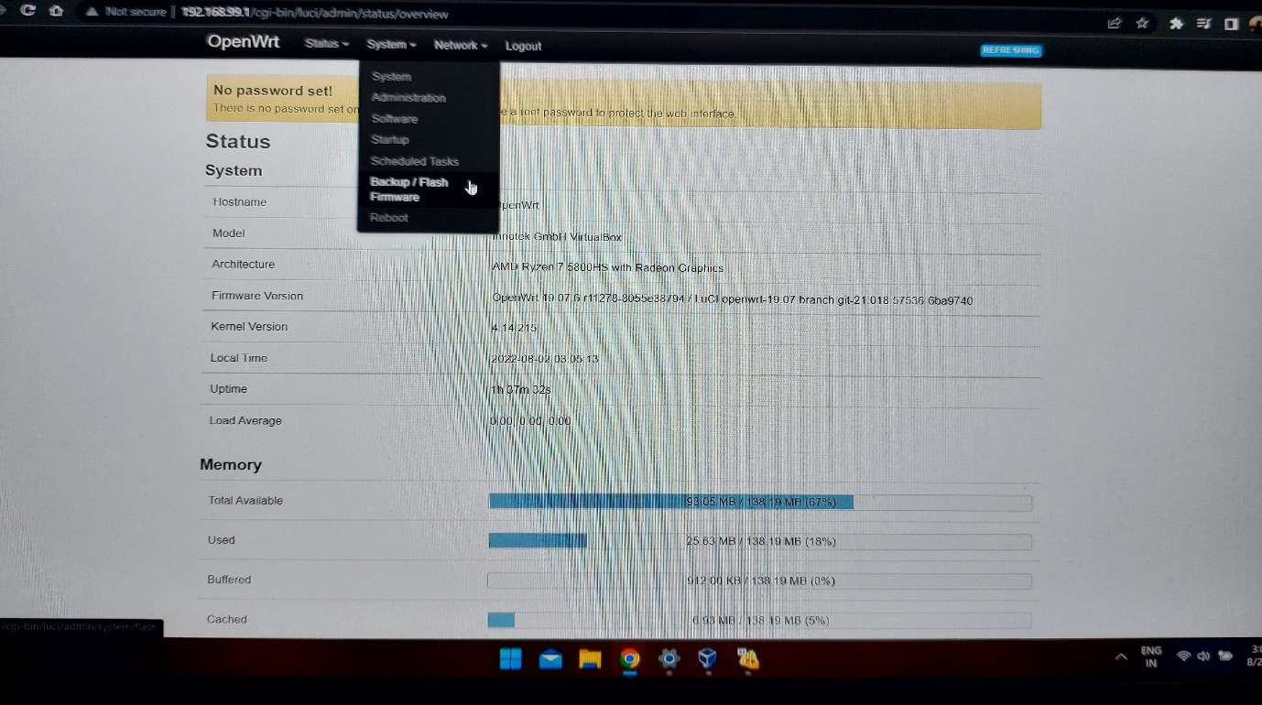

* Its awalys recommeneded to bacup the data before updateing

(just in case if anything goes wrong)

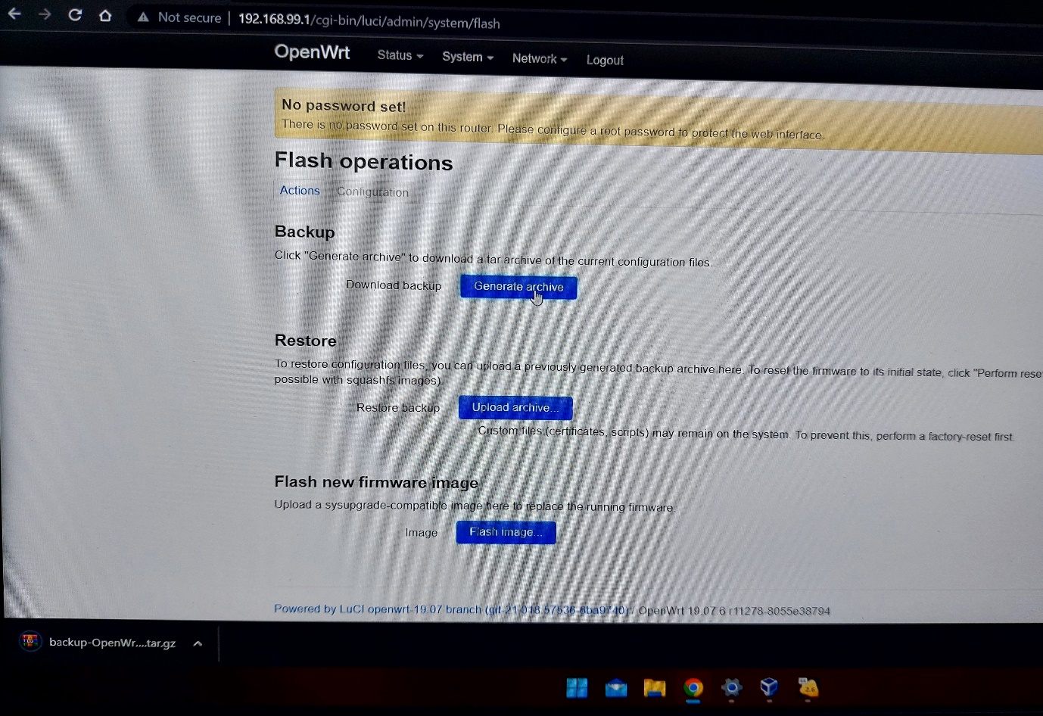

* Then click on flash new image firmware option

And add the update file and wait it for being uploaded

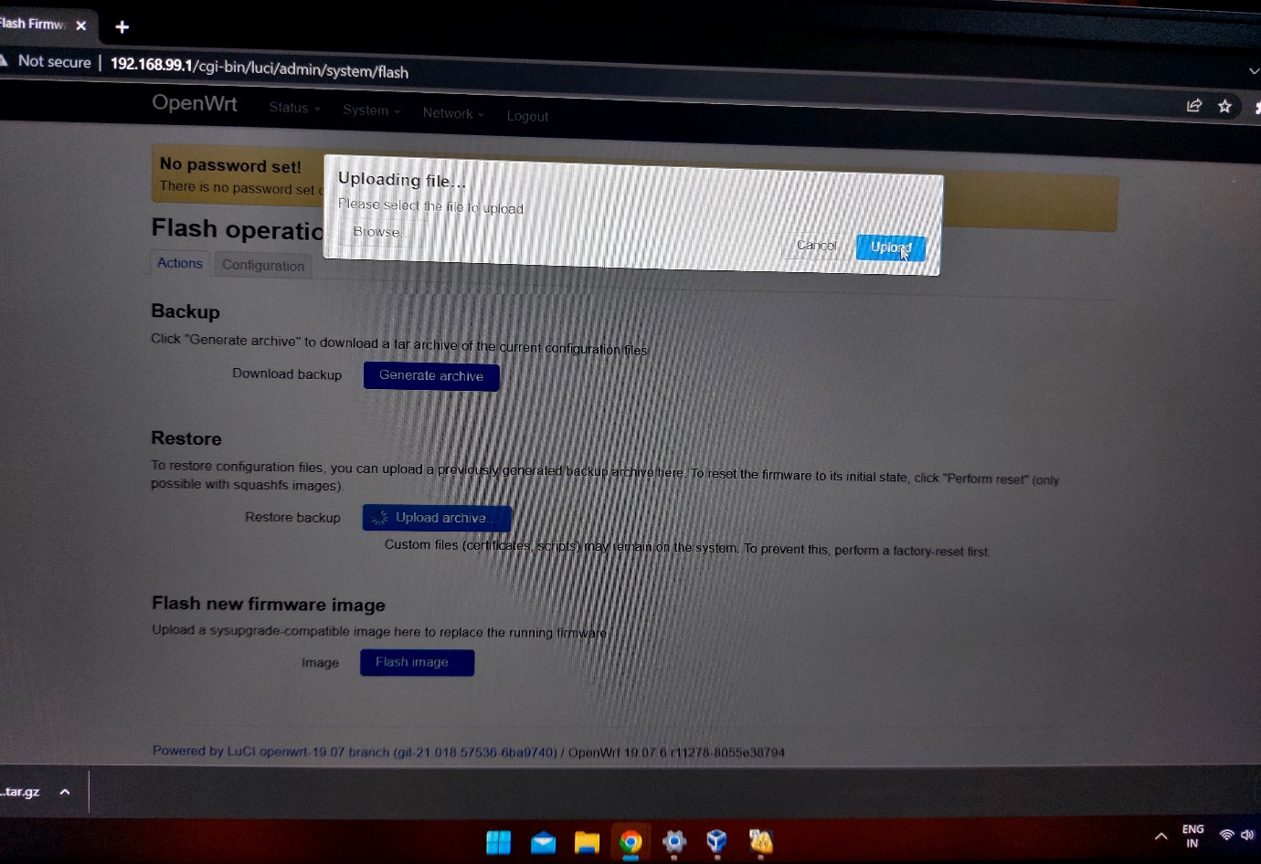

* Then at the end it will verify that if you really wanted to apply the firmware update
  + Then click on proceed to start the flashing process

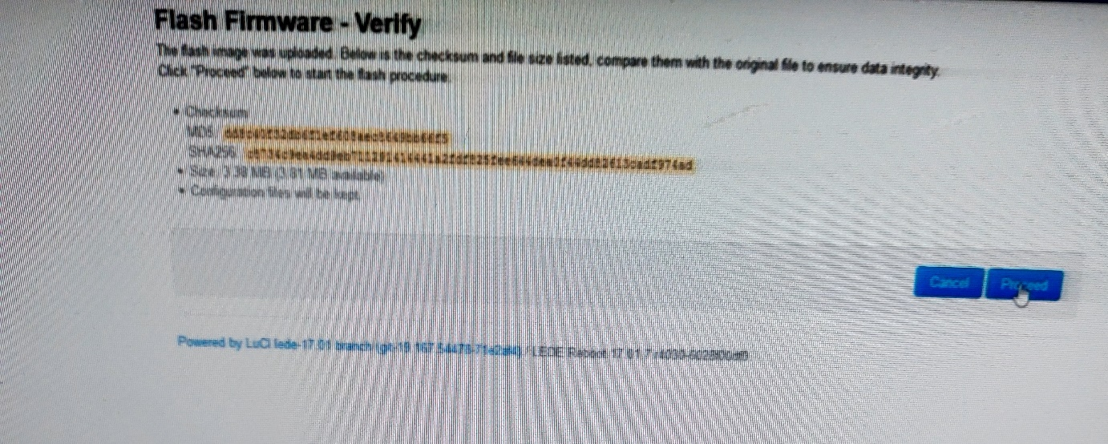

**Power off/Reboot the device**

* To power off the device
  + Use the command : poweroff

It will shut down the machine with all the saved settings

* and to reboot the device

use the command : reboot

